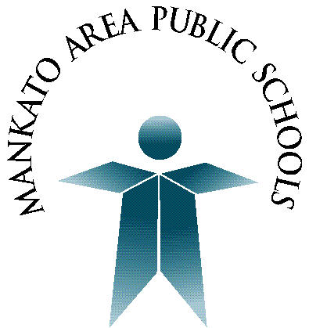
Mankato Area Public Schools

Continuing Education Committee

The Continuing Education Committee is scheduled to meet for 2021-22 on the following dates below. Meetings will be held in the Minnesota Valley Room.

November 4, 2021 12:30 - 3:30 PM

January 27, 2022 12:30 - 3:30 PM

March 16, 2022 4:00 - 6:00 PM

May 12, 2022 12:30 - 3:30 PM

